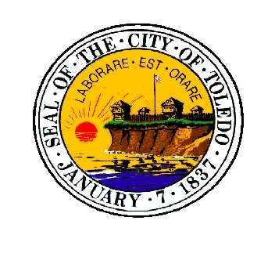

Toledo City Council

Committee of the Whole

Council President Carrie Hartman, Chair

Councilman George Sarantou, Vice Chair

will conduct a committee hearing on

Wednesday, January 15, 2025
One Government Center – City Council Chambers
3:00 PM

The purpose of the meeting is to discuss:

Mayor’s Office Budget Presentation
Toledo City Council Budget Presentation
Budget Amendments

Any other matter that may properly come before the Committee.
The Clerk of Council’s Office supports the provisions of the Americans’ with Disabilities Act. If you need special accommodations, please call 48 hours prior to meeting time at 419-245-1060 for arrangements.

